**A**

**Technical Seminar Report**

**On**

**The Next Revolutionary Autonomous Vehicle Technology**

Submitted To

**Jawaharlal Nehru Technological University, Hyderabad**

In Partial Fulfillment of the Requirements for the award of Degree of

**BACHELOR OF TECHNOLOGY**

**In**

**COMPUTER SCIENCE AND ENGINEERING**

**By**

**K.Pravalika**

**Roll No. 19N61A0522**

**Under the esteemed guidance of**

**Dr. M. V. Hanumanth Reddy**

**Assistant Professor**



**DEPARTMENT OF COMPUTER SCIENCE AND ENGINEERING**

**vivekananda Institute of TECHNOLOGY & Science**

**(Approved by AICTE New Delhi, Affiliated to JNTU, Hyderabad)**

**Karimnagar-505001**

**2019-2023**

**vivekananda Institute of TECHNOLOGY & Science**

**(Approved by AICTE New Delhi, Affiliated to JNTU, Hyderabad)**

**Karimnagar-505001**

**DEPARTMENT OF COMPUTER SCIENCE AND ENGINEERING**



**CERTIFICATE**

This is to certify that the Technical seminar report entitled “ **The Next Revolutionary Autonomous Vehicle Technology**”, is submitted by **K.PRAVALIKA** bearing Roll No. **19N61A0522** in IV year I semester B. Tech Computer Science & Engineering .

**Co- Ordinator Head of the Department**

**Guide Principal**

**vivekananda Institute of TECHNOLOGY & Science**

**(Approved by AICTE New Delhi, Affiliated to JNTU, Hyderabad)**

**Karimnagar-505001**

**DEPARTMENT OF COMPUTER SCIENCE AND ENGINEERING**



**DECLARATION BY THE CANDIDATE**

I, **K. Pravalika** , bearing Roll No, 19N61A0505, hereby declare that the Technical report titled “ **The Next Revolutionary Autonomous Vehicle Technology**” submitted in partial fullfilment of the requirements for the award of the degree Bachelor of Technology in Computer Science & Engineering.

This is a record of bonofied work carried out by me and the content and result embodied in this report have not been submitted to any other university or Institute the award of any other degree or diploma.

**K. PRAVALIKA,**

**19N61A0522,**

**DEPARTMENT OF COMPUTER SCIENCE & ENGINEERING,**

**VIVEKANANDA INSTITUTE OF TECHNOLOGY & SCIENCE,**

**Karimnagar-505001.**

**Abstract**

Autonomous vehicles also commonly known as driverless or self-driving vehicles, are automobiles that require no human involvement for operating or controlling them. In recent years, advancement in automated vehicle[1] concepts has progressed but still some human input is required, depending upon the level of automation. Experts anticipate that automobiles will be capable of driving themselves within 3-7 years. This paper describes current status, recent trends and research of selfdriving vehicles in the automobile industry. A detailed analysis of the technologies used by automated vehicles to sense their environment and the level of automation in such vehicles is also included. The expected short-term and longterm, positive and negative, beneficial and harmful impacts of driverless technology such as greenhouse gas emission, energy consumption etc. are assessed. As widespread adoption of self-driving vehicles is considered to be inevitable, therefore requirement of certain technical and legal guidelines will be essential for safe and tension-free travel. The potential concerns regarding autonomous vehicles must be discarded with safe policies and technologies as discussed in the paper.

**Keywords**

Autonomous cars, sensor technologies, carbon emission, LIDAR, impacts, applications.

**Table of Contents**

* Introduction
* Current status and Research
* Levels of Automation
* Sensor Technologies
* Physical key components of Autonomous vehicle
* Recent Developments
* Impacts and Applications
* Major Applications
* Potential Concerns
* Advantages and Disadvantages
* Conclusion
* References

**INTRODUCTION**

Automated vehicles have been generating significant attention and discussion, recently with almost every automobile company trying to develop their respective autonomous vehicle concept and are successful in achieving some levels of autonomy and are planning to start production of driverless vehicles in few years. Even though people have mixed feelings of excitement and insecurity regarding the driverless concept but will either accept or reject it on the basis of the impacts of autonomous vehicles. Researchers and analysts have already started considering the effects of autonomous vehicles on carbon emission, number of cars per person, etc. and are providing their views on vehicle automation. Self-driving cars will need to outperform human driving capabilities for securing a larger consumer market. But surely, it will have a huge impact on the timeline of transportation and a landmark in human inventions.

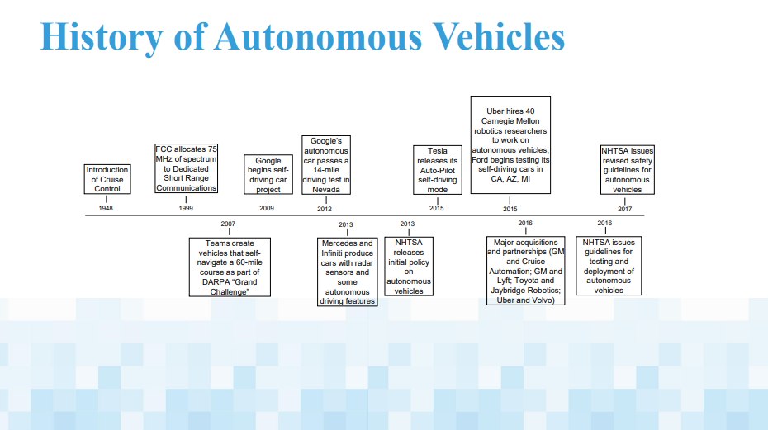

CURRENT STATUS AND RESEARCH

The automotive industry is rapidly evolving and now with the concept of self-driving cars, all the companies are focused on developing their own driverless cars. Even the companies which are not into ‘mainstream automobile’ like google and uber are also investing and researching extensively in autonomous vehicles.

● Apple is also developing its self-driving car project “Titan”.

● The concept of electric cars is already in practical use. Tesla and General Motors have successfully launched their respect electric cars in the market and are available to the consumers. But the autonomous vehicles are still in research but cars with some levels of autonomy are available like Tesla autopilot and GM super cruise control.

● An MIT spin-off called I See is developing and testing autonomous driving system using artificial intelligence. Also, an object detection system called YOLO (you only look once) developed by Joseph Redmon is being used in driverless vehicle concept.

● Component maker Faurecia has envisioned the cockpit for the autonomous car. When autonomous mode is selected, the steering wheel folds away and the screen behind it slides to the centre of the dashboard.

● Waymo, the subsidiary of parent company of google is a self-driving technology company which is successfully testing its concept car.

● Waymo has also announced to launch self-driving trucks for delivering goods.

● Companies are launching concept cars like Aston Martin launched its concept car Lagonda Vision Concept, which is a luxurious electric, level 4 autonomy car.

● Renault has launched its autonomous concept car called SYMBIOZ which drives in manual or level 4 autonomous mode. Many more advances are being done in this field rapidly but the aforementioned points are mentioned to show the seriousness and enthusiasm regarding vehicle automation. The attached graph represents the future timeline regarding the adoption of autonomous vehicles by the public.

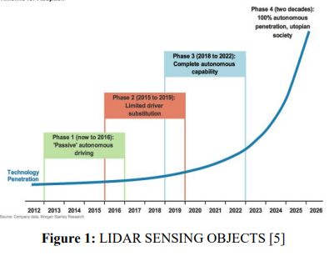

LEVELS OF AUTOMATION

The classification of automated vehicles is done with dividing them on the basis of extent of automation. The first classification was given by National Highway Traffic Safety Administration (NHTSA), USA in 2013. But in 2016, SAE presented its classification of six levels of automation which was set as the international standard for all automated vehicles.

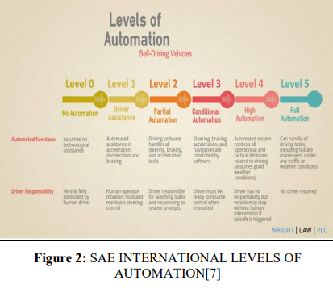

LEVEL 0: NO AUTOMATION Vehicles in which all the controlling operations are in driver’s hands. The piloting, braking, acceleration, deceleration and emergency braking is done solely by the driver. Vehicles with basic warning systems like coolant temperature, oil pressure etc. also fall in this category.

LEVEL 1: DRIVER ASSISTANCE Some specific control functions that assist the driver in operating are included in level 1 cars. The driver is responsible for all operations but vehicle provides assistance if he utilizes it. Lane Keeping Assistance (LKA) steers the vehicle into a particular lane and Adaptive Cruise Control (ACC) is also an automated system which regulates speed and the driver steers. All the automated systems work independently and still require some input from the driver. Nowadays, this level of automation is seen in most cars like Honda civic, jeep, BMW.

LEVEL 2: PARTIAL AUTOMATION In partial automation, the vehicle has control of the vehicle in terms of steering, acceleration/deceleration and braking but the driver must monitor the driving and should be ready to take control at any time in case the automated systems are unable to perform. Level 2 automated cars are available in market and include two or more combined automated functions.

LEVEL 3: CONDITIONAL AUTOMATION In limiting self-driving, the vehicle is in full control and alerts the driver to retake control in situations which require driver assistance. The driver can take his ‘eyes off’ the road and should take control when the system needs it. Vehicles with level 3 automation usually use RADAR technology for sensing their surroundings. Tesla autopilot system, General Motors super cruise technology and Audi A8 have level 3 automation.

LEVEL 4: HIGH AUTOMATION Vehicles in this level are capable of handling immediate response like emergency braking. Driver attention is not required and need not be in the driver seat. But driver can take control in unusual environment conditions. Google car prototypes fall under this category.

LEVEL 5: FULL AUTOMATION No human involvement is required. The vehicle will not allow the passenger to take control of the operations. Robotic taxi will fall under this category.

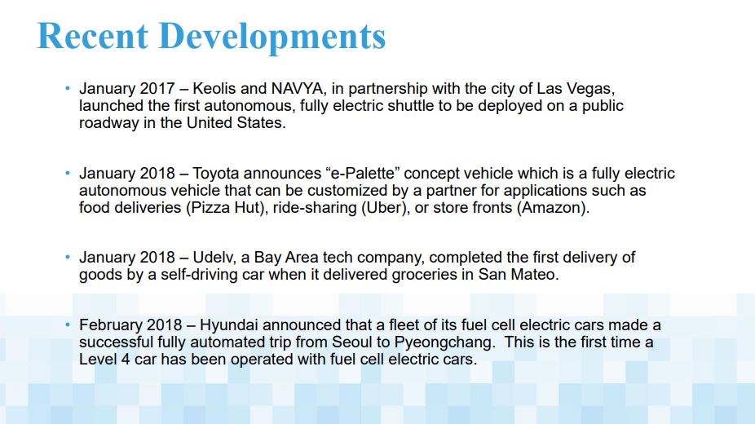

**SENSOR TECHNOLOGIES**

Autonomous vehicles are being developed using complex algorithms and neural networks and advance technologies. In this section, technologies used by vehicles to sense their environment have been assessed.

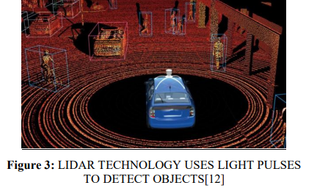

ULTRASONIC SENSORS :

Ultrasonic sound waves are sound waves having frequency greater than 20,000 hertz. Sensors use these sound waves to locate nearby obstacles, the waves hit any object and reflect back thus mapping the surrounding and accordingly give the output back to the system.

▪ SONAR used in submarines and boats use same concept.

▪ Bats are able to navigate using a similar technique called echolocation.

▪ Ultrasonic sensors are useful in automated parking but can be used only at low speeds.

IMAGE SENSORS :

In image sensing, a number of cameras are placed in the vehicle to generate images of the surrounding. Traffic lights and signs are easily interpreted. Image sensors are hard to use in fog, rain or night. RADAR SENSORS Radio Detection and Ranging (RADAR) sensors emit high frequency radio waves which echo after hitting an obstacle and a tuned antenna picks up the signal and informs the system about the object position and speed.

▪ Radars are widely used in ships and aircrafts.

▪ Currently, radars are being used in some semiautonomous vehicles like Tesla.

▪ The reflected signals are hard to trace back in an open field or very packed space.

LIDAR SENSORS :

To overcome the difficulties with radars, Light Detection and Ranging (LIDAR)was developed. Lidar sensors use low intensity and harmless laser beam to scan the environment. The data from the sensors and cameras are processed together in the master software which creates a real time virtual 3D environment. But lidar sensors are much more expensive than radar sensors. Google car and Uber self-driving taxis use lidar sensors.

BASIC KEY COMPONENTS

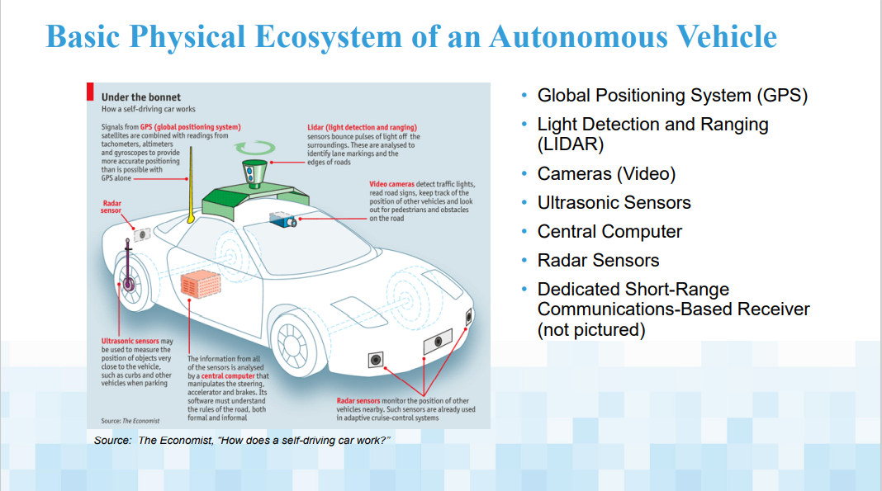

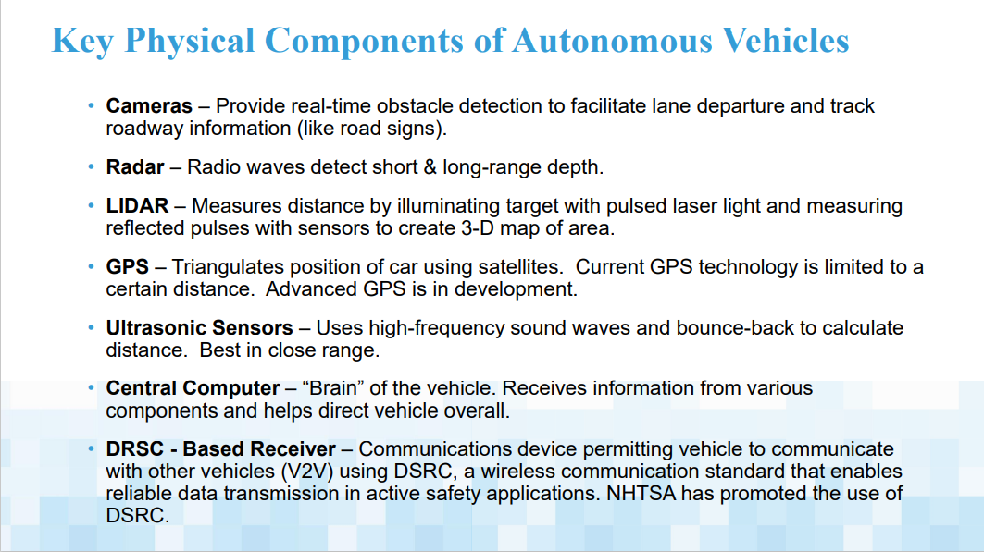

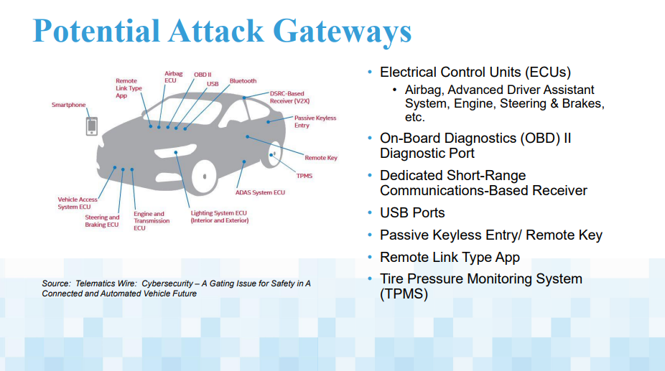

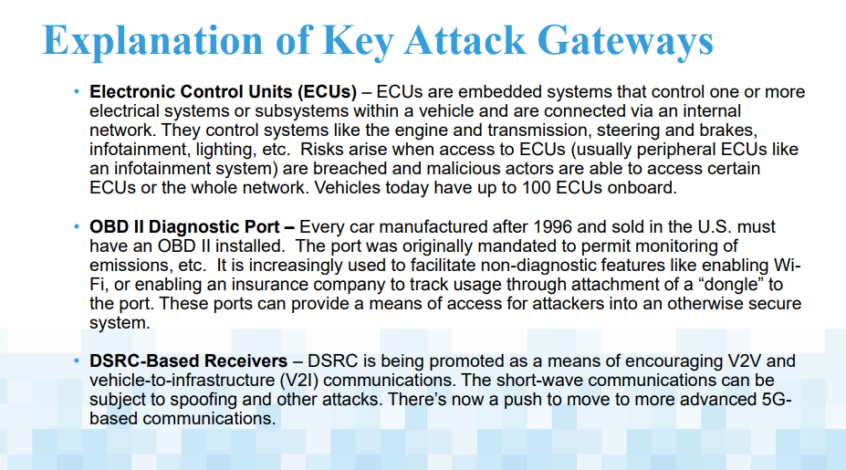

**IMPACTS AND APPLICATIONS**

In this section the expected impacts of autonomous vehicles on economy, carbon emissions and people’s behaviour are discussed. Autonomous cars would cause a decrease in number of accidents as it does not get distracted nor gets tired and also is packed with safety features like ABS and airbags. The driving will be free from human errors and will safe huge losses of life and money. Also, cases of road rage will reduce effectively. Drivers will have time for anything else other than driving which could be used for relaxing, working or for entertainment, thus adding up to the revenue of telecom industry for example, if internet is used while traveling therefore improving economy.

Platooning refers to when multiple vehicles move closely to each other, reducing aerodynamic drag on the cars in the middle, thus increasing efficiency and decreasing fuel rate consumption. Platooning will be possible by automated vehicles as there is no delay in perceiving and reacting to speed changes whereas in manually operated cars platooning can be dangerous. It will also reduce road congestion as cars would move in tight formations. The speed limit can be increased as there is no chance for the computer systems to get distracted. Emissions released by automated vehicles will be increased or decreased depending upon the human behaviour.

Either the driverless concept would cause increase in energy consumption or would dramatically decrease it. People may tend to go on long drives or trips to far-away places as they would not have to drive and commuting in cars would become easy and tension-free. Also, if people rather pick the self-driving taxis, it would reduce pollution and energy consumption.

MAJOR APPLICATIONS

● Driverless cars can be used as regular cars for driving from home to work.

● Autonomous vehicles can be used as self-driving taxis, where the passengers just have to input the destination. Uber has already started trials for driverless vehicles offering lifts to customers.

● The delivery trucks deliver goods across countries travelling via long and dangerous routes, in harsh road and weather conditions. Self-driving trucks would be very essential for delivering through such conditions.

● It can be used by older people, people with disabilities and people who do not know how to drive.

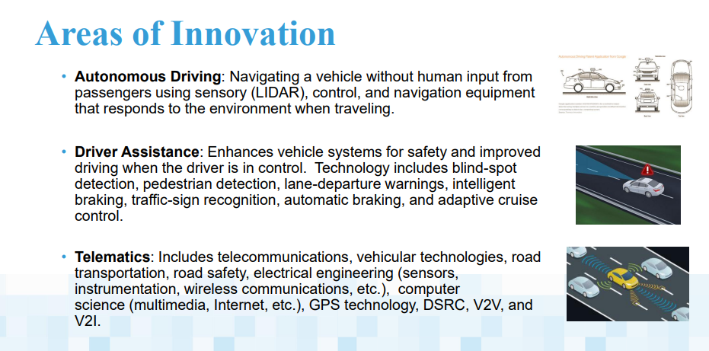

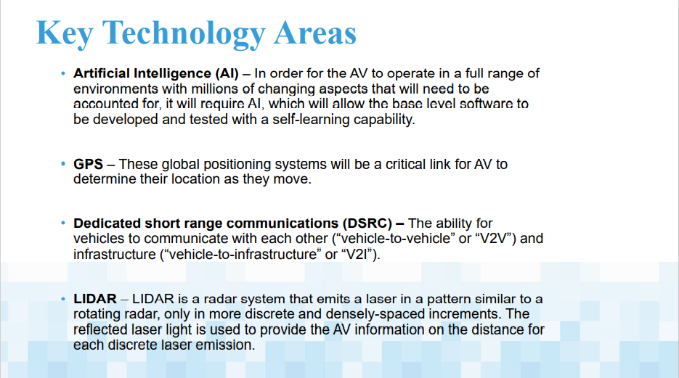

Potential Concerns

The concept of self-driving cars is creating excitement in people but at the same time some concerns are also being brought up regarding the technical, safety and law aspects of driverless cars. The potential challenges are listed below;

● Busy city streets with bustling traffic and incoming pedestrians will be a challenge for the autonomous cars.

● Difficult village roads or rough mountain roads which are uneven and bumpy and filled with potholes, the speed of the car must be controlled and ability of steering away from bumps or holes will be tested.

● The software and computer system of the car can be reprogrammed to disable the safety features with the intention of causing an accident.

● The sensing of objects or people become difficult in different weather conditions like snow, rain, etc.

● Also sensing around corners is very difficult and inability to track incoming traffic around the corner can be catastrophic.

● Autonomous cars may require very high-quality specialised maps to operate properly. Where these maps may be out of date, they would need to be able to fall back to reasonable behaviours.

● The confusion in transmitting and receiving signals in case of radar and lidar.

● The car must be able to recognize animals and avoid it by steering away from it or stopping, depending on the conditions.

● The cost of maintenance and repair of the car will be very high.

● The car would have to be tested and the internal systems including the software would have to be checked from time to time to avoid any failure on the road.

**ADVANTAGES**

Let’s look at the main advantages brought by autonomous vehicles:

**360**° **vision :** Thanks to high-precision technology, autonomous vehicles possess the ability to view the environment in a **360° range**, twice as much as humans, who have a viewing angle of only 180° horizontally.

* **Reduced accidents :** Thanks to 360° vision and vehicles being interconnected with each other and in constant communication, **accidents will be significantly reduced**. Although (at least initially) accidents will not be reduced to zero, they will be much less than accidents caused by human driving.
* **Higher traffic efficiency :** Although it is estimated that their speed in big cities will be lower, their traffic efficiency will be higher.
* **Access to the disabled and people with reduced mobility :** Thanks to the fact that the automobile will be autonomous and will require practically no human interaction for its operation, even **people with visual or hearing disabilities** will be able to have one, i.e., they will become inclusive.
* **Sustainable vehicles :** It is expected that these vehicles will operate based on clean energy, so carbon and greenhouse gas emissions will be practically zero.

**DISADVANTAGES**

Let’s look at the main disadvantages of autonomous vehicles.

* **Data protection issues :** The first problem that arises, is in that, being connected all the time with the whole environment, it can become a cyber problem of data protection. Even the correct handling of road networks can be compromised.
* **High cost of implementation :** Autonomous vehicle infrastructure revolves around 5G network coverage, which is still expensive, so it may take governments considerable time to invest in sufficient infrastructure for optimal performance of autonomous vehicles.
* **High cost of vehicles :** Although significant progress has been made in reducing the cost of producing their implements, these cuts are not low enough to make them a financially viable alternative for the average family. It will be some years before they become an everyday reality within the reach of the middle class.

**FUTURE**

The autonomous vehicle of the future will have a heavier reliance on camera technology, especially since new camera technology such as wide-baseline stereo vision can generate direct 3D measurements at long range-and since future platforms will be strongly driven by both safety and cost considerations.

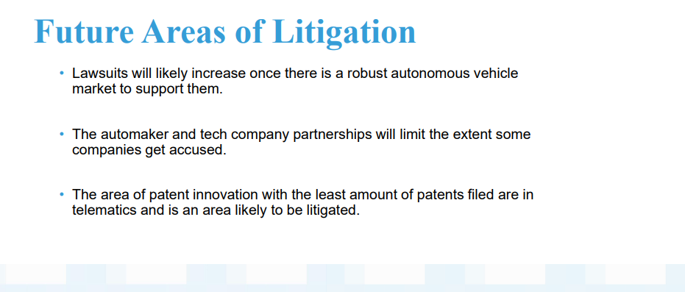

**CONCLUSION**

Autonomous vehicles have been subject to research and development for nearly a century. Current vehicles employ a combination of laser mapping systems, cameras, and sensors to read terrain, other vehicles, and traffic lights. Google Chauffeur is the most advance software system to date. Weighing out the pros and cons.V2V communication is in the near future. Cars will no longer be thought of as simply a transportation option, but rather a mobile entertainment center equipped with Wi-Fi, televisions, and a entertainment dedicated onboard computer. Japan has already begun to employ autonomous vehicles in the trucking industry.